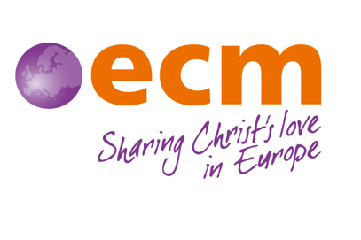
ECM Ireland Director
Job Advertisement

An exciting opportunity has arisen for an inspiring, wise and strategic leader to take forward the work of European Christian Mission Ireland.
ECM Ireland’s mission is to ‘Equip, connect and multiply followers of Jesus through Church Planting and Discipleship across Europe’ which we do in partnership with ECM International. The ECM Ireland Director is appointed by, and accountable to the Council of the mission, and works together with office staff, council members and volunteers to recruit, deploy and support our mission workers and seeks to promote the work in which they are involved. In addition, the office mobilises Christians in Ireland, both north and south, to help build a different Europe, through prayer and financial support.

We are looking for a new Director who can help us achieve our mission by:
- Providing leadership and strategic oversight
- Overseeing and managing human resources
- Providing effective governance and stewardship of ECM Ireland’s resources
- Leading and contributing to the communications of ECM Ireland
We would like the postholder to have a professional qualification in Theology, Management, Business or equivalent, have previous management experience, and training in pastoral care or similar.
This role is for someone who can provide vision, leadership, inspiration, and direction, who has excellent organisational and management skills and can work independently and as part of a team. Regular communication with the 40 plus mission workers across Europe, through zoom, email and where feasible, travel, is a central aspect of the Director’s work.
There is an occupational requirement for the post-holder to be a committed evangelical Christian who is in full agreement with the ECM Ireland Doctrinal Statement and the vision, purpose, and values of ECM Ireland.
This is a permanent post, either part time at 32 hours per week or full time at 40 hours per week, with a six-month probationary period.
Contact Details:
If you would like more information, or an informal chat about the role, please contact the ECM Ireland Director, Lindsay Moorhead, at lindsay.moorhead@ecmi.org
To apply, please send your CV, along with a covering letter (max. 300 words), detailing how you fulfil the requirements of this role (as outlined in the person specification) for consideration by the Council’s interview panel. Applications should be sent by email to Lindsay Moorhead at Lindsay.moorhead@ecmi.org
Only candidates who are eligible to be employed in the UK should apply for this role.
Closing date: 19th October at 12.00 noon.

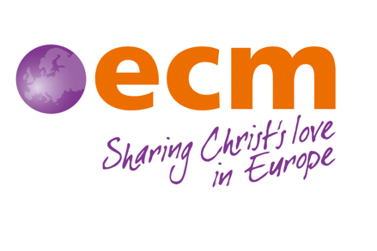
ECM (European Christian Mission) Ireland
Director Job Description

Job Title: Director
Reports to: ECM Ireland Council
Duration and location: This is a permanent role (32 or 40 hours per week), based in the ECM Ireland office in Lisburn with some travel required. There is a probationary period of six months.
Remuneration: Based on 50% salary and 50% personal support, with the salary component based on NJC pay scale SO1 (currently starting at £28,226). Agreed salary will be dependent on applicant.
Date: September 2022

Primary purpose of the role:

The Director is responsible to the ECM Ireland Council for the leadership of the work of the mission in line with ECM’s agreed strategy and goals. The Director will be responsible for overseeing the management of the ECM Ireland office and staff team, recruiting new mission workers, and contributing to the pastoral care and oversight to our existing mission workers who are serving across Europe. The Director will also be required to develop relationships with key church leaders and to raise the profile of ECM across Ireland.

The Director will be required:

- To provide leadership and strategic oversight
- To serve and report to the ECM Ireland Council, in achieving the aims and objectives of the organisation though heading up the formulation and implementation of strategy in all areas of ministry
- To inspire, develop and ensure the effective performance of the ECM Ireland team
- To network with and maintain good relationships with key church and mission leaders
- To contribute to and stay abreast of mission thinking and strategy in Europe, through participation in conferences, networking with mission thinkers
- In conjunction with the Operations Manager, to oversee ECM Ireland’s staff and volunteers
- To actively participate in ECM International leadership bodies especially the Mobilisation Leadership Team and to work in partnership with other Mobilisation Teams when possible

- To oversee and manage human resources
- To oversee and contribute to providing wise pastoral care for over forty mission workers who are serving with ECM across Europe. This will involve regular communication via zoom and email and where feasible, travelling to visit our mission workers in person
- To work with the Operations Manager to ensure that each member of staff/volunteer is well cared for, has a current job description, a regular review, and is equipped to do their role well.
- To meet with prospective new candidates and guide them through the candidate selection process
- To build relationships with sending churches and field leaders
- To oversee candidate orientation and debriefing for both short and long-term mission workers and their families
- To provide crisis care and maintain a network of people who can help.
- To provide effective governance and stewardship of ECM Ireland’s resources
- To work with the Operations Manager to ensure that adequate systems of financial management are in place with the necessary trained staff to implement them.
- To work with the Finance Committee to produce a yearly budget and long-term financial plan
- In conjunction with the ECM Ireland Council and Operations Manager, to ensure that ECM Ireland’s financial policies are up to date and to oversee the development of effective fundraising policies and strategies to maintain and develop the objectives of ECM Ireland
- To ensure, in conjunction with the Operations Manager, that all statutory legal requirements are met, and that adequate systems and practices of administration are in place and functioning

- To lead and contribute to the communications of ECM Ireland
- To represent ECM Ireland at church meetings and other events and conferences
- To be involved in interagency meetings and conferences including MAP and IMAP
- To oversee the development and implementation of ECM Ireland’s communications
- To raise 50% personal support and to communicate with personal supporters regularly

This job description reflects the requirements of the post at the time of writing. The needs and circumstances may change over time, and therefore the job description may need to be reviewed in the light of any such changes which may occur.

The jobholder will be part of a team based at the ECM Ireland office in Lisburn and they must model and reflect the Christian ethos, mission, vision and values of ECM Ireland in all aspects of the role and be able to explain them to others. There is, therefore, an occupational requirement for the post-holder to be a practising Christian in line with our ethos and statement of faith.

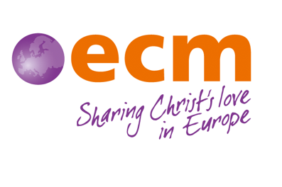
ECM Ireland Director Person Specification

Education and Knowledge:
Essential
- 5 A*-C GCSEs or equivalent, including Maths and English Language
- A relevant degree or professional qualification in Theology, Business, Management or similar
- Trained or equipped in pastoral ministry, member care or discipleship
- Excellent written and verbal English
Desirable
- 3 A-levels or equivalent, or an ability to demonstrate experience in a relevant employment context
- A good understanding of mission and particularly the spiritual and social situation in Europe.

Experience:
Essential
- At least 2 years’ experience in a management role
- At least 2 years’ experience in a role involving pastoral support/discipleship/member care
- Wide experience and competence in using Microsoft Office, particularly Excel, Word, Outlook, and SharePoint
Desirable
- Involvement in mission, particularly in Europe.
- Working within the Christian or charity sector.

Skills and Abilities:
Essential
- Outstanding interpersonal, written, and verbal communication skills
- Has the ability and experience to provide pastoral support and care to a wide group of people
- Can travel to various parts of Europe, to visit our mission workers, on a regular basis
- Can work on own initiative, independently and as part of a team
- Has excellent organisational and administrative skills with a high attention to detail, while keeping an eye on the bigger picture
- Strategic thinker
- Project and people management skills

Personal Qualities:
Essential
- A committed evangelical Christian who is in full agreement with the ECM (European Christian Mission) Ireland’s Doctrinal Statement* and the vision, purpose, and values of ECM Ireland.
- Has a positive character, able to motivate and inspire others. A desire to lead by example.
- Proactive, personable, reliable, and self-motivated individual.
- Excellent team player wanting to contribute to the overall ministry of ECM Ireland.
- Active prayer and devotional life, attending a local church regularly.
- Full UK Driving Licence or equivalent

The above serves as a guide and is not exhaustive. You will be part of a small team who work together to meet ECM Ireland’s aims and objectives.
*There is an occupational requirement for the post-holder to be a committed evangelical Christian and committed to the ethos and aims of European Christian Mission Ireland.

